Model Training
DisAERNet is an atmosphere–surface feature decoupling model designed for aerosol remote sensing retrieval tasks. The core objective of this model is to separate effective feature expressions related to atmospheric aerosols from multi-source remote sensing observation features, while minimizing the interference of surface background differences on aerosol retrieval. The model first utilizes site-matched samples for pre-training; through a feature decoupling module, it separately generates surface features and atmospheric features. Subsequently, the decoupled atmospheric features are fed into downstream machine learning models for further training and retrieval of aerosol parameters such as AOD, fAOD, cAOD, or FMF.
Data Preprocessing
The input data required by DisAERNet are site-matched sample data in .csv format. According to the current configuration, the model uses train_land.csv, valid_land.csv, and test_land.csv as the training set, validation set, and test set, respectively. These files mainly include temporal information, multi-band remote sensing radiometric features, observation geometry angle features, aerosol labels, surface indices, and land use types.
Label Data
Label data are used for model pre-training, validation, and testing, and typically include the following categories of fields:
1. Time and Site Information
For example, date, year, month, day, season, Obs_time, hour, Latitude, Longitude, etc., which are used to record the observation time, spatial location, and site information of the samples.
2. Remote Sensing Observation Features
These mainly include multi-band radiometric features in the visible, near-infrared, short-wave infrared, and thermal infrared regions, such as Lt_VN02, Lt_VN03, Lt_VN04, Lt_SW01, Lt_SW02, Lt_TI01, Lt_TI02, etc. These variables are the primary inputs for the model to identify mixed atmospheric and surface signals.
3. Observation Geometry Features
For example, scatter_ag, Sensor_zenith, Solar_zenith, and angle variables corresponding to different bands or channels. These features describe the observation relationship among the sun, sensor, and surface, and are important factors affecting atmospheric radiative transfer and aerosol retrieval.
4. Aerosol Label Variables
Including AOD, fAOD, cAOD, and FMF, etc. Among them, the target_col in the current train.json configuration file is set to fAOD; therefore, the current training task uses fAOD as the default target variable.
5. Surface Background Variables
Including MNDWI, NDVI, BSI, NBDI, NDSI, NDISI, on_land, and Landuse, etc. These variables can characterize different surface cover types and surface reflectance backgrounds, and are of great significance for achieving atmosphere–surface feature decoupling.
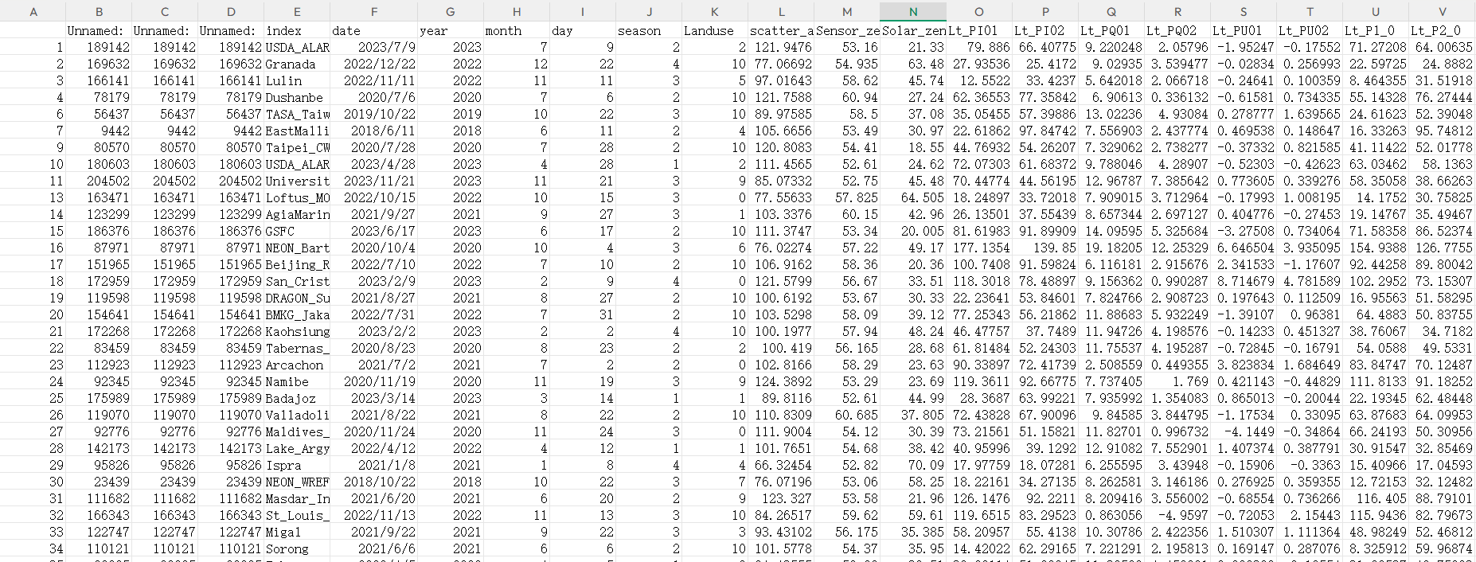
Parameter Configuration
The main parameters of DisAERNet are configured through the train.json file. Users typically only need to modify the data paths, output paths, target variables, and model parameters in the configuration file to complete training tasks for different datasets or different aerosol parameters.
Continuous input variables are specified by cont_cols, mainly including multi-band radiometric features and angle features; categorical variables are specified by cate_cols, with month currently used as the categorical variable; the surface type selection field is Landuse; and the target variable is fAOD. In terms of model parameters, the current pre-training epochs are set to 50, fine-tuning epochs to 10, batch size to 128, learning rate to 0.0003, and feature projection dimension projector_size to 10.
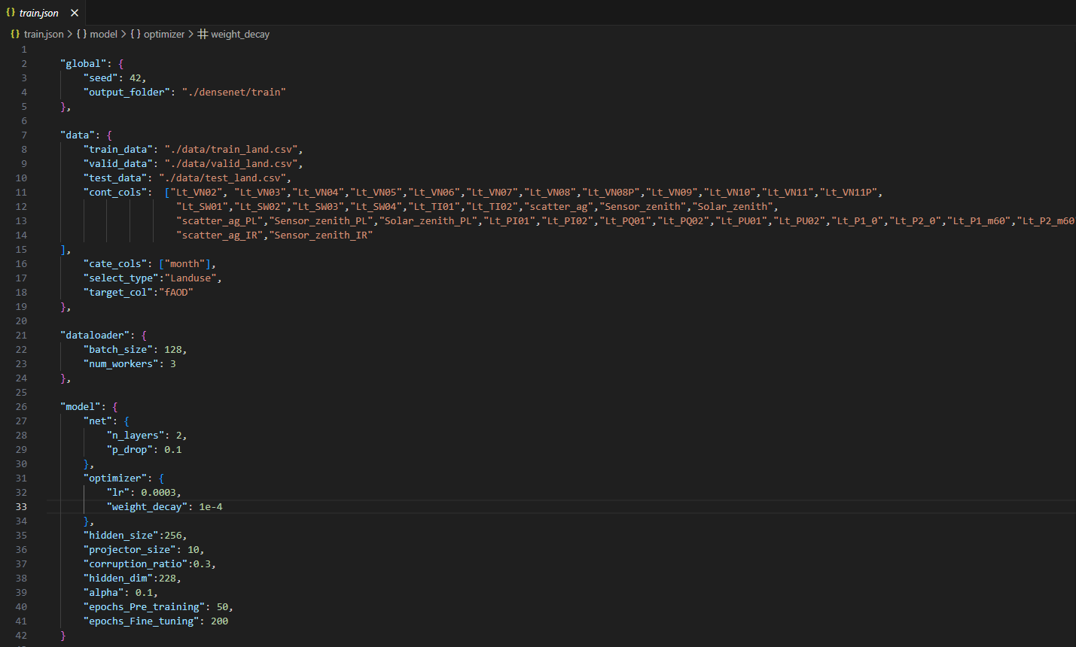
Model Pre-training and Feature Decoupling
After completing the parameter configuration, the first step is to run the pretrain script for DisAERNet pre-training. This step is the core of the entire workflow, and its main function is to learn mixed feature representations from remote sensing observation data and further decompose them into surface-related features and atmosphere-related features.
During the pre-training process, the model takes multi-band radiometric features, observation geometry features, month information, and land use type variables as inputs. Through feature encoding and decoupling modules, it extracts latent feature expressions from the samples. Among them, surface features are mainly used to characterize different surface cover types, vegetation conditions, bare soil/water body backgrounds, and surface reflectance differences; atmospheric features focus on retaining information related to aerosol optical properties, providing more stable inputs for subsequent aerosol retrieval.
After pre-training is completed, the model outputs the generated surface features and atmospheric features to a specified folder. These output files are the foundation for subsequent downstream model training and inference. Among them, atmospheric features are usually used as the primary input for subsequent training of machine learning models such as XGBoost; surface features can be used to check whether the model has effectively separated surface background information, and can also be used for comparative analysis of the impact of surface differences on aerosol retrieval.
Further adjustments to training parameters and data inputs can be made by examining the feature separation status in the outputs.
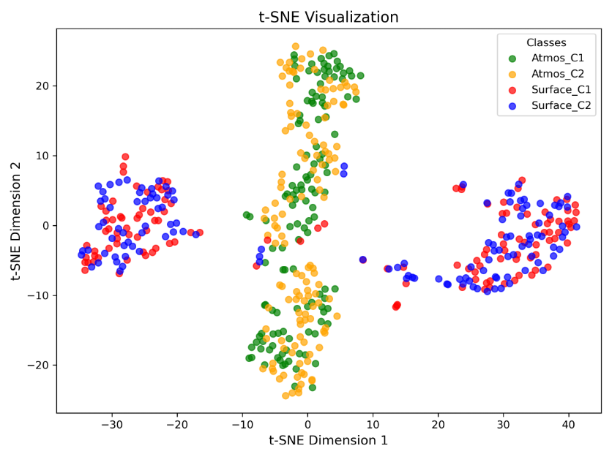
Downstream Model Training and Site Inference
After completing DisAERNet pre-training and generating decoupled features, the next step is to run the prexgboost script. This step mainly feeds the atmospheric features extracted by DisAERNet into the downstream XGBoost model to train and infer site samples for corresponding dates. Specifically, prexgboost first reads the atmospheric feature files output during the pre-training stage and matches them with the original site label data. Subsequently, the model uses atmospheric features as input variables and the target aerosol parameter as the output variable to establish a downstream retrieval model. In the current configuration, the target variable is fAOD; therefore, the downstream model performs fAOD retrieval by default. If AOD, cAOD, or FMF retrieval is required, the target_col parameter in the configuration file can be modified.
After site inference is completed, the model outputs prediction results for corresponding dates or samples. These results can be used to evaluate the retrieval accuracy of the model at the site scale, such as calculating R², RMSE, MAE, Pearson correlation coefficient, and other metrics. Scatter plots of predicted values versus true values can also be drawn to verify the effectiveness of DisAERNet decoupled features for aerosol retrieval.
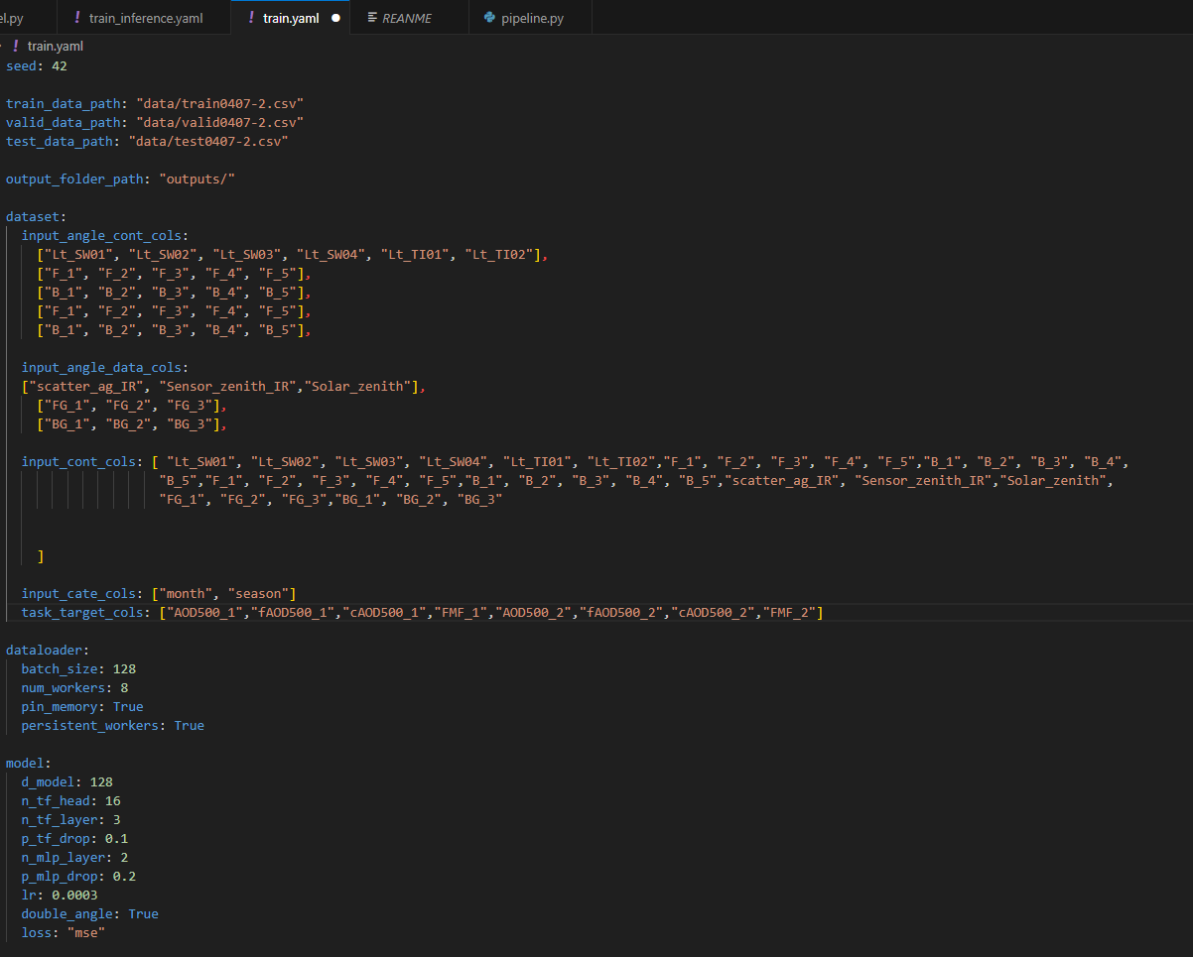
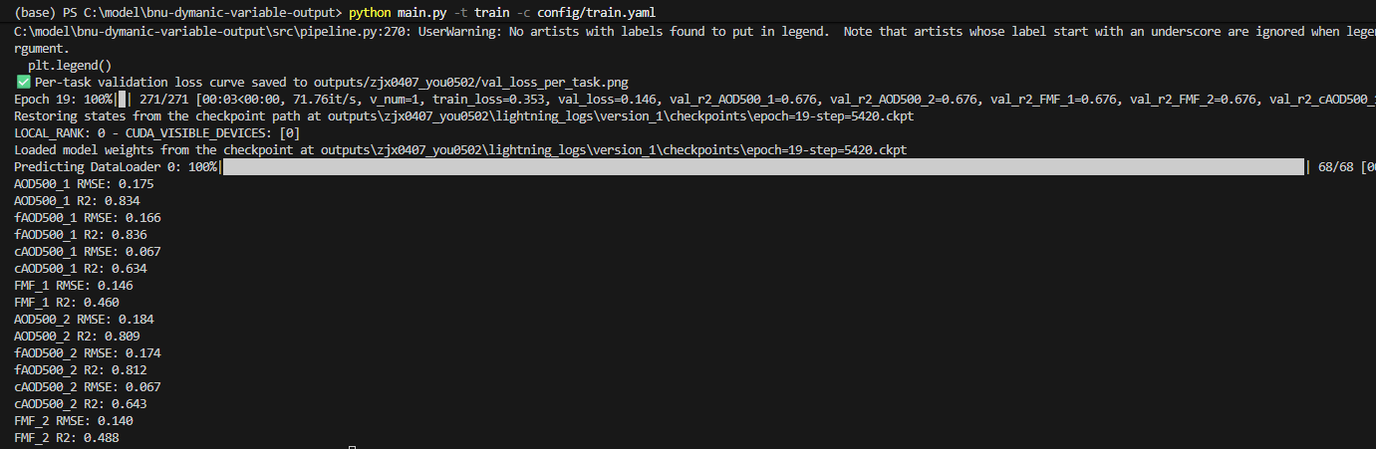
Regional Scale Inference
After completing site-scale model training, larger regional scale inference can be further carried out. Typically, remote sensing observation data within the target retrieval area need to be organized into an input format consistent with the training samples, including the same band features, observation geometry features, month variables, and surface type variables. Subsequently, using the feature extraction capability obtained during the pre-training stage, atmospheric features are first generated for global pixel data, and then these atmospheric features are fed into the trained downstream XGBoost model to ultimately obtain global-scale aerosol parameter retrieval results. The key to this workflow is maintaining consistency between the site training data and the inference data in terms of field names, variable order, data preprocessing methods, and missing value handling methods. Only when the input data format is consistent with that of the training stage can the model perform stable spatial extrapolation.

